Synoptic Meteorology II

**Lab 2: QG Vorticity Equation**

Wednesday, February 15th, 2023

(100 pts)

Name:­­­­­­­ ________________________________________________________________

Due: February 22nd, 2023, at 11:59 pm

**Learning Objective**:

* To diagnose contributions to midlatitude synoptic-scale cyclone motion using the forcing terms from the QG vorticity equation.

**Things to know:**

Feel free to use the Internet and collaborate with your colleagues when answering these questions. For Part III, the requested plots must be obtained using the Jupyter Notebooks on our JupyterHub before you can complete the questions.

**Part I: Idealized Synoptic-Scale Systems (35 pts)**

Consider the following idealized 500 hPa geopotential height analysis. Assume that the mean background zonal wind speed is approximately 20 m/s and the zonal wavelength is approximately 4000 km.

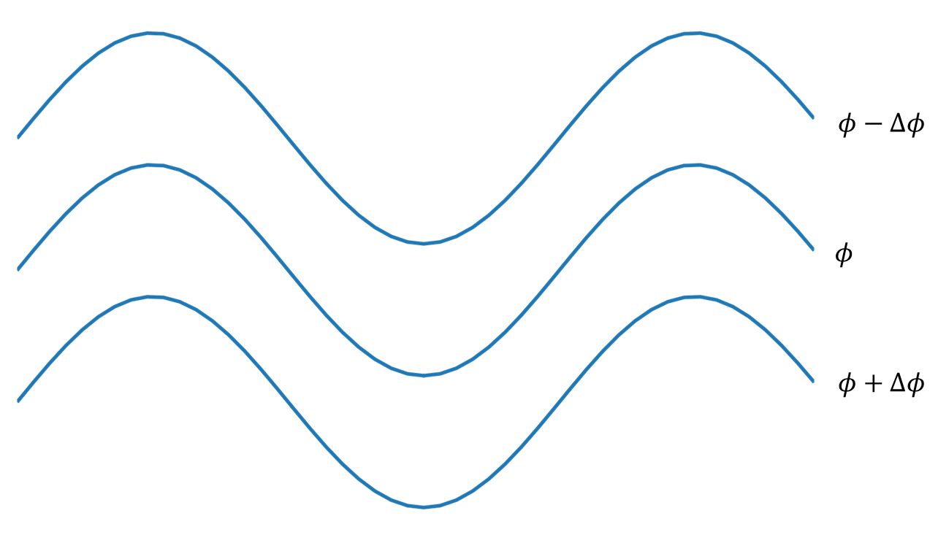

1. Sketch/label each of the following on the figure:
   1. Locations of locally maximized and minimized $ζ_{g}$ (5 pts).
   2. Ridge and trough axes, using their appropriate symbols. (5 pts)
   3. The vorticity gradient vector on the west and east sides of the trough axis (5 pts).
2. Will this wave pattern move? If it moves, in what direction will it propagate? Explain using quasi-geostrophic reasoning. Note: There is no need for you to calculate each forcing term; just provide a general interpretation/approximation of the terms (10 pts).
3. Indicate (by sketching on the figure) the locations of maximized cyclonic (CVA) and anticyclonic (AVA) vorticity advection. What is happening to the heights in these areas? (10 pts)

**Part II: Shortwave vs. Longwave Troughs (35 pts)**

Answer the following question using the definition of the geostrophic relative vorticity:

$$ζ_{g}=\frac{g}{f}∇^{2}Φ =\frac{g}{f}\left(\frac{∂^{2}z}{∂x^{2}}+ \frac{∂^{2}z}{∂y^{2}}\right)$$

where the second partial derivative can be approximated as:

* 1. Use centered finite differences to calculate the geostrophic relative vorticity at the indicated point in the trough’s base on the figure below. Show all work. (10 pts)

* 1. Use centered finite differences to calculate the geostrophic relative vorticity at the indicated point in the trough’s base on the figure below. Show all work. (10 pts)

* 1. Which wave is associated with greater cyclonic geostrophic relative vorticity? Why? (5 pts)
  2. Assume that the horizontal wind speed and direction are identical in the trough’s base for both examples above. What effect will the resulting difference in geostrophic relative vorticity advection have on the behavior of the waves? (5 pts)
  3. Describe how these differences would affect the evolution of the geopotential height field just to the east and west of the trough’s base. (5 pts)

**Part III: Identify Shortwave + Longwave Trough Movement in Real-Time (30 pts)**

1. Find one shortwave and one longwave trough within the continental United States taking place within the next week using model data. Show the movement of each trough with at least two upper-air maps. Which trough moved the quickest? Explain. Include the maps you created in the JupyterHub when you turn in the lab. (30 pts)

Note #1: The movement of each is frequently affected by the amplification and de-amplification of the trough, a phenomenon to be discussed in the next lab. If you can, find two cases where this occurs as little as possible.

Note #2: Your explanation accounts for 20 out of the 30 points available for this question. The remaining 10 points are reserved for completing your Python code and how well your maps follow the “good map” guidelines.

**Part IV: Predicting Local Geostrophic Relative Vorticity Changes (Graduate Students Only; 10 pts)**

1. Using the quasi-geostrophic vorticity equation, explain mathematically **and** physically how the geostrophic relative vorticity will change over the next few hours at the location of the A on the map below (10 pts).

$$\frac{∂ζ_{g}}{∂t}= -{\vec{v}}_{g}∙∇ζ_{g}-βv_{g}+f_{0}\frac{∂ω}{∂p}$$

